**Batch: H2-4 Roll No.:16010122257**

**Experiment 05**

|  |
| --- |
| **Title: Working with time-series data.** |

# Objective:

# *Search/locate and download the time series Data*

# *To learn how to visualizetime series data*

# *Applying trend line over visualized time series data using analytics options*

# *Perform forecast over the time series using analytics options*

# Course Outcome:

# CO1: Learn how to locate and download datasets, extract insights from that data and present their findings in a variety of different formats.

# CO3 Apply data visualization best practices

# Books/ Journals/ Websites referred:

[**https://www.tableau.com/solutions/time-series-analysis**](https://www.tableau.com/solutions/time-series-analysis)

**Sosulski, K. Data Visualization Made Simple: Insights into Becoming Visual,**

**First edition, 2018**

[**https://www.pluralsight.com/guides/building-a-time-series-chart-in-tableau**](https://www.pluralsight.com/guides/building-a-time-series-chart-in-tableau)

# Resources used:

<https://www.kaggle.com/datasets/dougcresswell/daily-total-female-births-in-california-1959>

# Theory:

# Definition Time series:

(Theory related to experiment needed to perform - Students should write)

A time series is a sequence of data points, typically measured at successive points in time. It is used to represent and analyze patterns, trends, and behaviors in various fields, such as economics, finance, weather forecasting, and more. Time series data helps us understand how a particular phenomenon changes over time, allowing for predictions and analysis based on historical patterns.

Time series forecasting is essential for many organizations, enabling them to compare various dimensions over time, detect trends, and identify seasonal patterns within the data. This statistical technique involves recording and analyzing data points over specific time intervals, such as daily, monthly, or yearly periods. A time series chart visually represents this data across these intervals.

Examples of time series analysis applications include analyzing stock market trends, studying population patterns through census data, and tracking sales and profit trends over time. Time series analysis helps organizations understand the underlying reasons behind trends and systemic patterns. Data visualizations aid business users in observing seasonal trends and investigating the causes behind these patterns. Modern analytics platforms allow for advanced visualizations beyond traditional line graphs.

In time series analysis, quantitative data points are arranged chronologically, creating a statistical series. There are four key components in a time series:

Secular Trend: Represents the long-term movement in the data.

Seasonal Variations: Reflects recurring seasonal changes within the data.

Cyclical Fluctuations: Corresponds to periodic but non-seasonal variations.

Irregular Variations: Represents other non-random sources of variation in the series.

In the additive model, a specific observation in a time series is represented as the sum of these four components. In the multiplicative model, these components have a multiplicative relationship, and an observation is represented as the product of these components.

# Following points should be written by students

# Observation after plotting of time series data

# Observation after plotting trend line (Linear, Exponential and polynomial)

# Observation after Forecast (Automatic, Additive, and multiplicative, along with season options)

# Note: Detail observation needed along screenshots wherever required

Observations

The data set chosen for this experiment was “Daily Total Births of Female in California”.TheCaliforniaFemaleBirthsdatasetisatimeseriessituationwherewe are trying to forecast future outcomes based on past data points. The problem is to forecast the daily number of female births in California. The dataset described a time-series of baby births over 12 months in 1959, and there are 365 observations.

The first graph gives a simple time series. It shows the Daily total female births in CaliforniaVsDay.Asthechartshowsdataishighlyvolatile.Itsbeenvaryingfrom 30 – 50 births in a day.

P.T.O

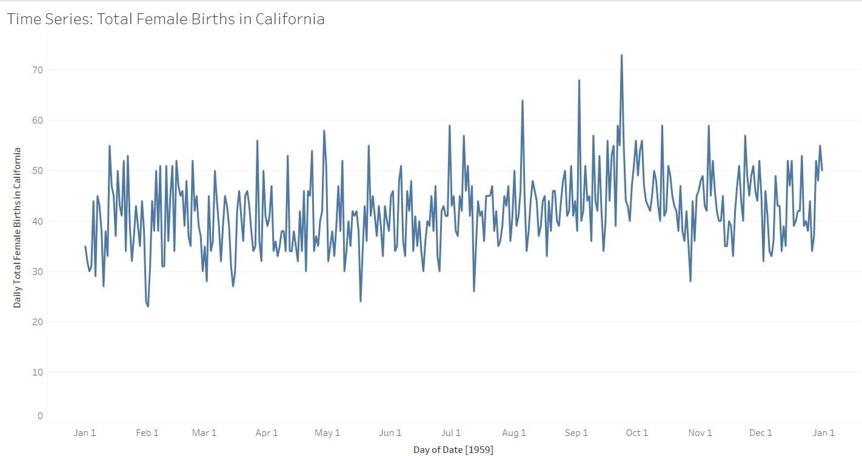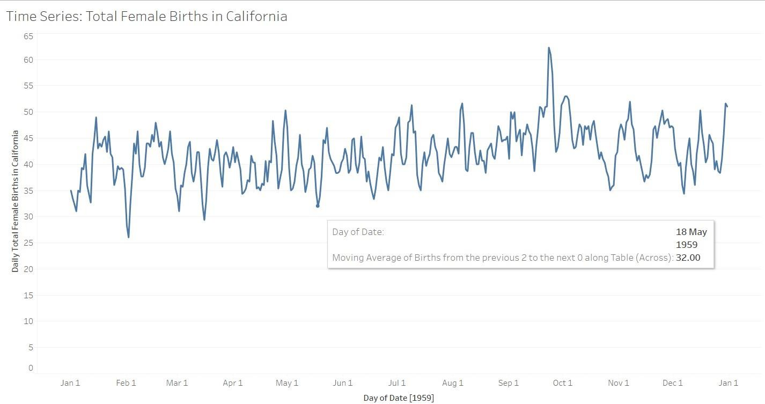

The next graph shows the moving average of Daily births vs Day graph. Moving Average gives a good idea of the temperature variations over the last years if we want to consider the reasons for change. It smooths out the noise by filtering short term variations.

The third graph shows a trendline (polynomial) which can be used to understand the trend over the years and also calculate the approximate births in the coming years. As we can see the trend line is gentle and shows low overall variations.

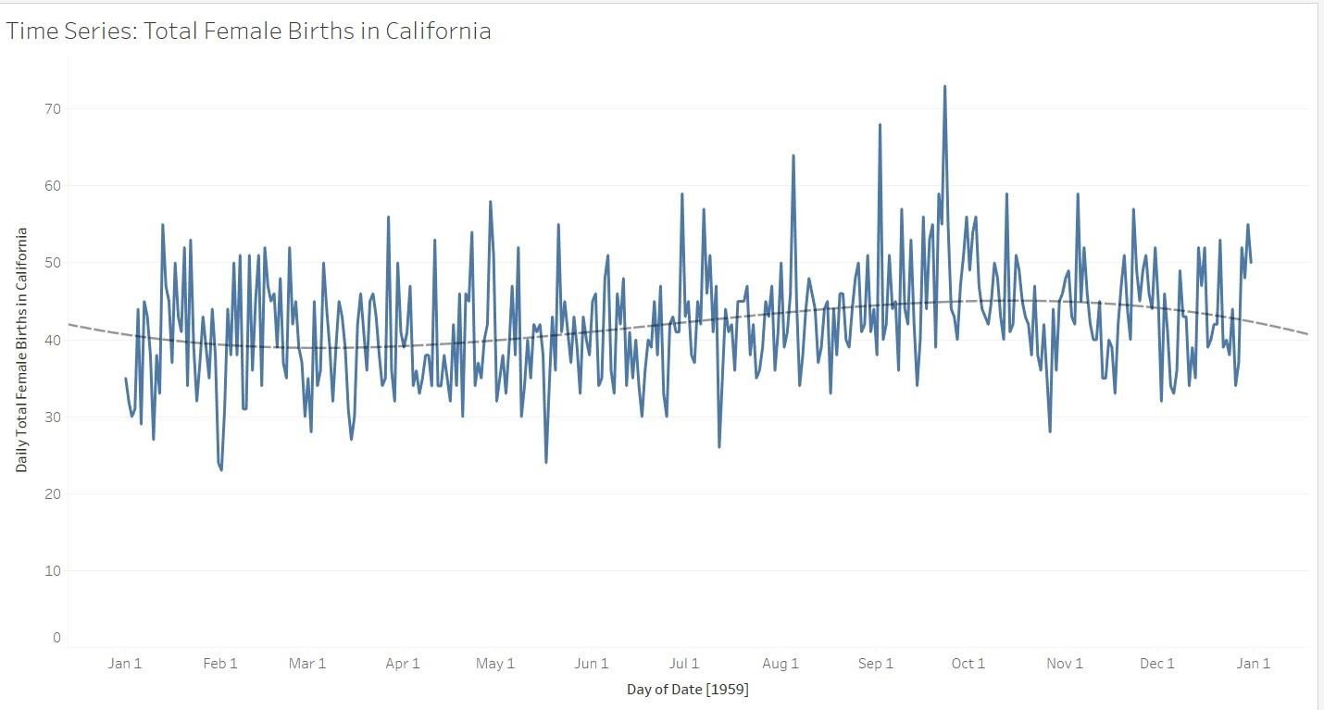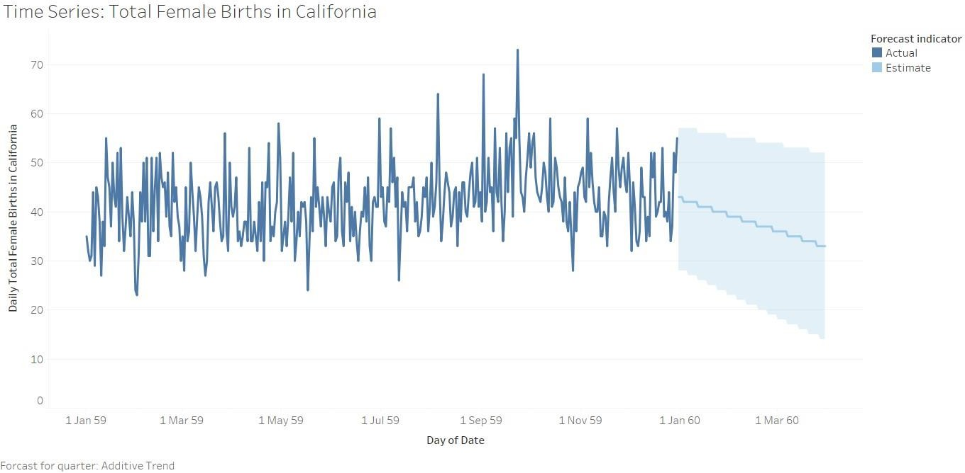

The next 4 graphs give a forecast of BirthsvsDay for the next quarter.The four forecasts take into consideration 4 models:

* + AdditiveTrend and Seasonality,
  + AdditiveTrend and AdditiveSeasonality
  + Additive Trend and MultiplicativeSeasonality,
  + Multiplicative Trend and Multiplicative Seasonality

The additive trend shows a decrease in no of births over the next quarter but rest of the model show a rather volatile yet average forecast for the next quarter, which shows that time is not affecting the average births.

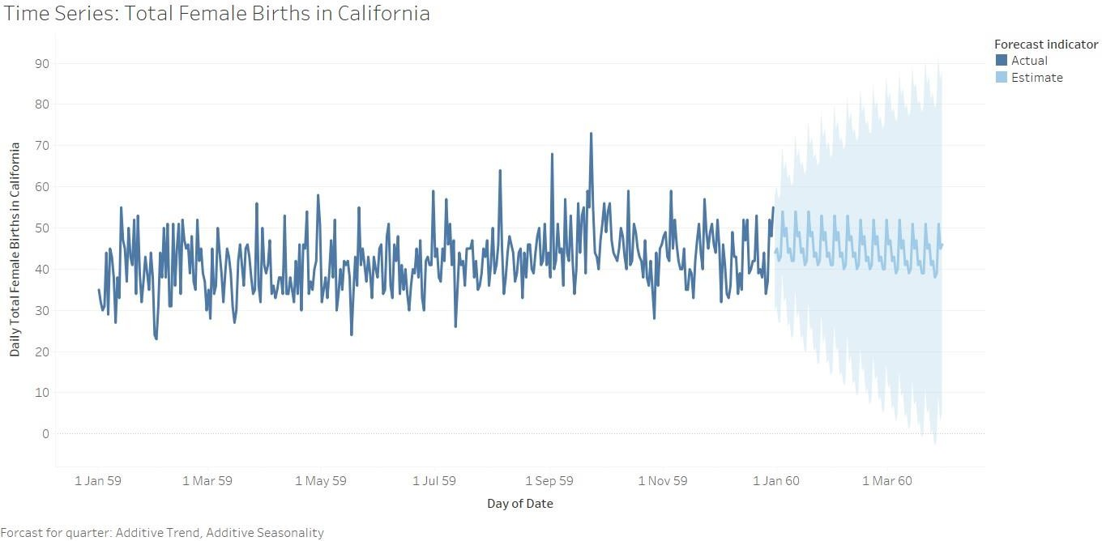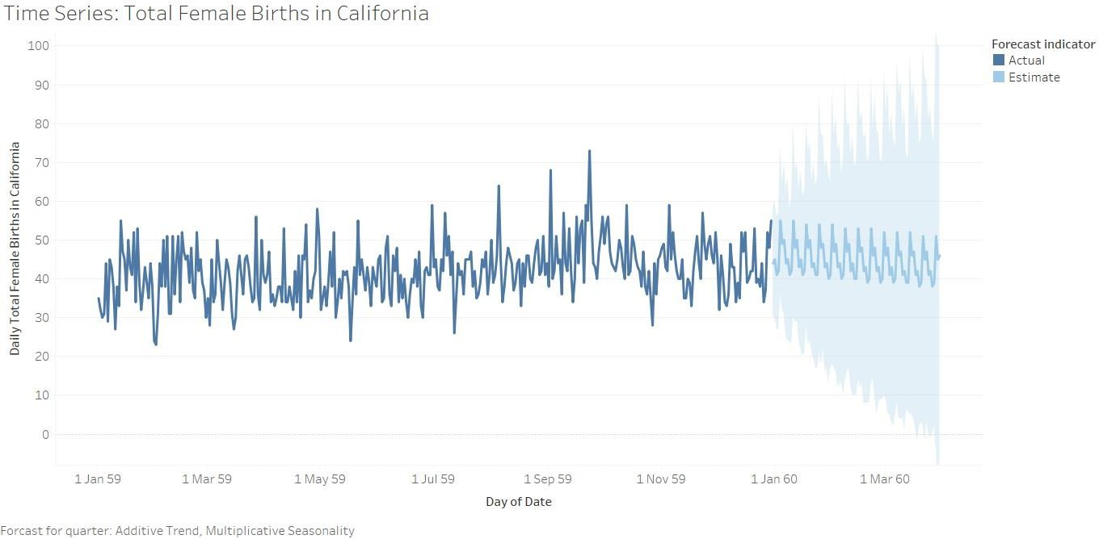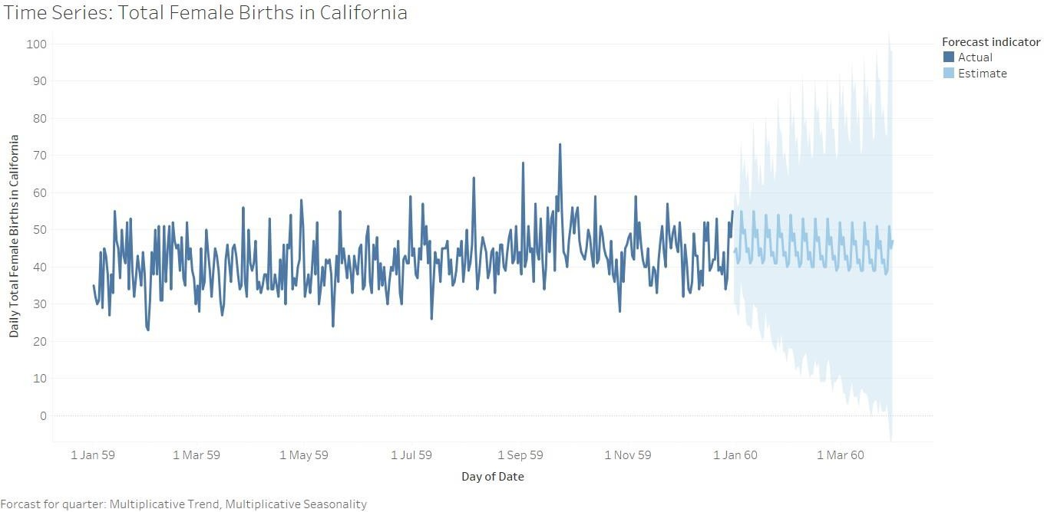

# Conclusion (Students should write in their own words, comparative conclusion needed): In summary, analyzing time-series data allowed us to uncover significant patterns and trends within the dataset. By employing techniques such as visualization, trend line analysis, and forecasting, we were able to gain profound insights into how the data behaved over different periods.

**Date: _____________ Signature of faculty in-charge**

# Post Lab Question:

# Compare the additive and multiplicative model of time series.

# Additive Model:

# Components:

# Trend: Represents the overall direction of the data, indicating whether it's increasing or decreasing over time.

# Seasonality: Denotes regular and predictable patterns that repeat at consistent intervals, such as daily, monthly, or yearly cycles.

# Residuals (Error): Signifies random fluctuations or noise in the data that cannot be attributed to the trend or seasonality.

# Equation:

# Additive Model: Time Series = Trend + Seasonality + Residuals

# Usage:

# Additive models are suitable when the magnitude of seasonal fluctuations remains relatively constant over time, irrespective of the overall trend.

# Interpretation:

# In the additive model, changes in the time series are added or subtracted linearly. Increasing the time period results in additive effects on the time series.

# Multiplicative Model:

# Components:

# Trend: Represents the overall direction of the data. In a multiplicative model, the trend is nonlinear, indicating exponential growth or decay.

# Seasonality: Similar to the additive model, it represents regular and predictable patterns.

# Residuals (Error): Represents random noise, but in a multiplicative model, it is proportional to the level of the series.

# Equation:

# Multiplicative Model: Time Series = Trend * Seasonality * Residuals

# Usage:

# Multiplicative models are appropriate when the magnitude of seasonal fluctuations changes with the level of the time series. For instance, when seasonal patterns become more pronounced as values increase or decrease.

# Interpretation:

# In the multiplicative model, changes in the time series are proportional. Increasing the time period doesn't just add effects but multiplies them, indicating exponential growth or decay.

# Comparison:

# Additive Model:

# Suitable for data with constant magnitude of seasonality.

# Changes in the time series are added or subtracted linearly.

# Easier to interpret when data fluctuations remain relatively constant over time.

# Multiplicative Model:

# Suitable for data where seasonality magnitude varies with the series' level.

# Changes in the time series are proportional, indicating exponential growth or decay.

# More appropriate when seasonal patterns become more pronounced as values increase or decrease.